Interaction Design Notes
University of cambridge, Part IA
Ashwin Ahuja
2018

Interaction Design 2
Requirements Analysis & Development 2
Gathering and Analysing Data 4
Data Collection Techniques 4
Data Analysis and Interpretation 6
Design Process and Prototyping 6
Participatory Design (User-Centred Design): 6
Task Analysis and Modelling 7
Task Model 8
Task Flow Diagrams 8
Principles of Good Design 8
Design Principles 8
Shneiderman’s Golden Rules for Interface Design 9
Cognitive Aspects for Design 9
Model Human Processor 9
Memory 10
Gestalt Psychology 12
Visual Perception 12
Rule Based Evaluation 13
GOMS and KLM 13
Fitts’ Law 14
Hicks Law 15
Heuristic Evaluation 15
Cognitive Walkthrough 17

Interaction Design

Requirements Analysis & Development
Idea of interaction design is iterative user-centred design and development
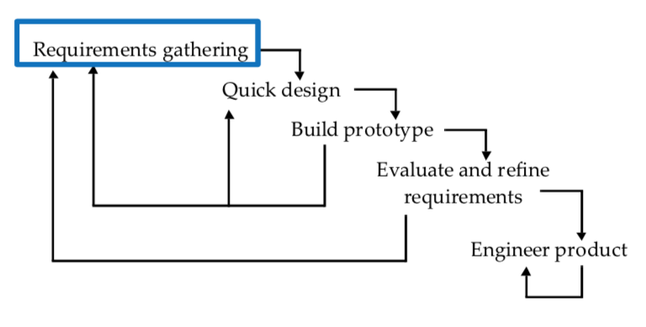
Requirements arise from understanding the users’ needs – establishing what is needed and what the system should accomplish.

Why?
- Things can go wrong
  - Ambiguous specification from customer
  - Designer misinterpretation
- Define requirements is where failure most often occurs
- Failure at this stage is expensive and time-consuming to fix

What?
- Requirement: What or how software should perform
- Aims:
  - (1) Identifying Needs: Understand as much as possible about users, task, context
  - (2) Establishing Requirements: Produce a stable set of requirements
- Activities (Iterative):
  - Data gathering
  - Data analysis
  - Defining requirements

Types
- Functional Requirements: What the system should do
- Non-functional Requirements: What are constraints on the system
  - Data requirements
    - Where is it coming from?
    - What kinds of data?
    - How will they be stored?
    - How long will it persist?
    - How accurate will the stored data be?
    - Which data representations are needed?
  - Environmental requirements
    - Physical
    - Social
    - Organisational
    - Technical
  - User characteristics
    - Demographics
    - ICT related abilities
    - Physical and mental disabilities
    - Preferences
  - Usability goals and user experience goals
    - Usability: effectiveness, efficiency, safety, utility, learnability, memorability
    - Experience: enjoyable, entertaining, aesthetically pleasing, motivating

How?
- Socio-technical models
  - CUSTOM Stakeholder Analysis – identifying the stakeholder (anyone who is affected by the success or failure if the system).
    - Stakeholder definition
      - Those who interact directly with the product
      - Those who manage direct users
      - Those who receive output from the product
      - Those who make the purchasing decision
      - Those who user competitor’s products
      - Primary – people who use the system (frequent, hands-on)
      - Secondary – people who produce input for the system, or receive output from the system
      - Tertiary – people who are affected by the system’s introduction, or will influence its purchase
      - Facilitating – people involved in the system’s design, development and maintenance
  - Requirements Development – understand the stakeholders
    - Aims – what does the stakeholder have to achieve, and how is success measured
    - Sources of satisfaction – sources of satisfaction, dissatisfaction and stress for a stakeholder
    - Knowledge and skills – what knowledge and skills does the stakeholder have?
    - Attitudes to work – what is the stakeholder’s attitude towards work and computer technology?
    - Work-group attributes – any attitudes that affects the acceptability of the product to the stakeholder?
    - Nature of activities – characteristics of the stakeholder’s task in terms of (1) frequency, (2) fragmentation, (3) choice of actions
    - Responsibility – any specific issues related to (1) responsibility, (2) security, (3) privacy
    - Working conditions – typical conditions in which the stakeholder is working?
- Soft Systems Methodology (SSM)
  - Considering the organisation as a whole – stakeholders and technology are components of the larger context. The learning and appreciation of the problem situation rather than in order to solve a problem.
  - Three elements:
    - (1) Rich picture – detailed description of the problem situation
      - Who are stakeholders?
      - What groups?
      - What tasks?
      - Using
        - Interviews
        - Observation of work practises
        - Interactive approaches
    - (2) Root definitions – stakeholder perceptions
      - Moves focus of analysis from the real-world situation to definitions of what stakeholders perceive the activities that are taking place
      - CATWOE
        - Clients – people who benefit or accept output from system
        - Actors – stakeholders who perform activities
        - Transformations – what changes lead to things changing in the environment
        - World View – how the system is perceived by a client
        - Owner – who the system belongs to
        - Environment – what factors influence the system
    - (3) Conceptual Model – constructed with the details of what the system has to do to meet the root definitions
      - Using transformation – (1) what is achieved and (2) how. They are listed hierarchically.

Gathering and Analysing Data
Aim: Collect (1) sufficient, (2) relevant and (3) appropriate data – stable set of requirements.

Data Collection Techniques
- Observation
  - Direct Observation in the field – seeing how problem is currently solved – whilst talking to the users
  - Indirect Observation – trying to emulate the same process – asking user to talk about what they are doing.
  - While clearly realistic settings, it is difficult to set up and intrusive.
- Interviews
  - (1) Unstructured (open questions), (2) Structured (closed questions), (3) Semi-structured (open and closed questions)
  - Useful to identify user’s subjective opinions
  - Deciding questions, things to avoid:
    - Long questions
    - Compound questions
    - Complex jargon
    - Leading questions
    - Unconscious biases
  - Can also use props
- Focus Groups
  - Used to identify conflicts in terminology or expectation from different groups.
  - Need to select participants to represent well the target users
- Card Sorting
  - Sorting cards into groups – interactive process
  - Provides:
    - Terminology
    - Relationship
    - Categories
  - Three types:
    - Open Card Sorting – no pre-stablished groupings
    - Closed card sorting – there is a pre-established grouping
    - Hybrid – some combination of the two
- Questionnaires
  - In order to elicit some specific information
  - Getting answers to specific questions from large dispersed group of people
  - Qualitative or quantitative data – use with other techniques
  - Types of questions:
    - Open Questions – respondent free to write whatever they want
    - Closed Questions – respondent selects answers from a set of presented possibilities
      - Simple checklist
      - Multi-point rating scale
      - Ranked order
  - Things to remember
    - (1) Question order important
    - (2) Need different versions for different populations
    - (3) Clear instructions needed
    - (4) Avoid long questionnaires – or have shorter version
    - (5) Decide whether phrases all positive, all negative or mixed.
    - (6) Clear purpose of study
    - (7) Anonymity is important
    - (8) Incentive
    - (9) 40% response rate good, 20% acceptable
- Studying Documentation
  - Good source of data about steps (and regulations) written down in manuals
- Researching similar products
- Web analytics
  - Focus on number of web visitors and page views

Choosing Techniques:
- Time
- Detail
- Risk
- Required knowledge
- Kind of task
- Need to involve all stakeholder groups – more than one representative from each
- Support process with prototypes and task descriptions
- Balance functional and non-functional requirements

Data Analysis and Interpretation
- Quantitative Analysis
  - Numerical methods – averages, percentages
  - Card Sorting analysis
    - Looking for commonalities of groups
    - For small projects simply looking works
    - For larger projects – cluster analysis
      - Similarity Rating – add up times two cards appear together and divide by number of groups
- Qualitative Analysis
  - Expresses nature of elements
  - Represented as themes, patterns, stories
  - Looking for critical incidents
  - Theoretical Frameworks – basing data analysis around theoretical frameworks provides further insight
    - Grounded Theory
    - Distributed Cognition
    - Activity Theory
    - Thematic Analysis

Design Process and Prototyping
Aim: How to optimise the user’s interaction such that it supports and extends the user’s activities in a useful, efficient and usable way.

Participatory Design (User-Centred Design):
Has the idea that the users are experts on their work situation – has three ideas:
- Work Focussed
  - Design concentrates on improving the workers’ environment, rather than requirements
- Collaborative
  - Designers and users collaborate at every step

Conceptual Design – abstractly describes the system’s intended behaviour
Physical Design – addresses specific, concrete layout and design issues
Interactive prototypes – allow the users to interact with the designs

Pipeline:
- Brainstorming
- Concept development – high level description of how a system is organised and operates. It allows designers to straighten out their thinking before they start laying out their widgets.
  - What is the driving concept or metaphor behind the design – need one concept to make a coherent design
  - Moodboard is a type of collage consisting of images, text and samples of object in a composition of the choice of the creator.
- Prototyping
  - Why?
    - Explore a design space through multiple iterations
    - Demo versions to users (get more objective feedback)
    - Develop designs – ‘thinking through making’.
    - Identify the most important features
    - Choose between alternatives
  - What?
    - Technical aspects, with workflows working and there being the screen layouts and information displays existing.
    - Describe the look-and-feel
  - Low fidelity
    - Rough designs – consideration of user use
    - Problems identified from trouble users have as they walk through the system
  - Types
    - Paper
    - Video
    - Form model
    - Wireframe
- Storyboarding
  - Shows a rough idea of user’s activities – presented as a sequential storyline
  - Helps user communicate with designers – what they do and how they do it
- Workshops

Personas:
- Used to capture a set of user characteristics – not real people but synthesised from real users.
- Brought to life with a name, characteristics, goals, personal background

Workshops:
- Provide a forum for discussion where designers and users can ask each other about their perspectives.
- Generally used to fill in gaps of understanding about the situation

Task Analysis and Modelling
What? Hierarchical composition of knowledge – HTA (Hierarchical Task Analysis).
Why? Understand how people currently perform work – and use it to inform design. The system will fail if it (1) doesn’t do what the users want and (2) is inappropriate for the user.

How?
- First identify (1) goals, then (2) the actions to meet the goals and (3) the sequential dependencies.

Task Model
- Task Decomposition (how is this task done)
  - Decompose the high-level tasks and break them down into their constituent subtasks.
  - At a lower level show the task flows, decision processes and screen layouts.
- Show sequencing from left to right
- Consistency
  - Checking tasks are broken down to the same level of sub-tasks.
- Issues
  - Does not scale well
  - Does not allow for
    - Overlapping tasks
    - Interruptions
    - Learning
    - Communication
  - Tends to concentrate on how things are already done

Task Flow Diagrams
Documents the details of specific tasks (serves to identify problems) – not only show the specific details of current work processes but may also highlight areas:
- Where task processes are poorly understood
- Where task processes are carried out differently by different staff
- Where task processes are inconsistent with higher level task structure

Principles of Good Design
We are concerned with the usability of the interfaces – refers to (1) how well users can learn and use a product to achieve their goals and (2) how satisfied they are with that process.

Important Questions:
- How easily to determine the function of the interface?
- How easily to tell what actions are possible?
- How to determine mapping from intent to physical movement?
- How easy to perform the action?
- How to tell what state the system is in?

Design Principles
These are generalised abstractions for thinking about different aspects of design – they are the do’s and don’ts of interaction design. They are derived from a mix of theory-based knowledge, experience and common-sense.

Common Design Principles
- Visibility - be able to work everything out
- Feedback – sending information back to the user about what has been done
- Constraints – restricting the possible actions that can be performed, helping prevent users from selecting incorrect options
- Consistency – interface to have similar operations and use similar elements for similar tasks
  - Internal Consistency – operations behave the same within an application
  - External Consistency – designing operations to be the same across applications and devices
- Affordances – refers to an attribute of an object that allows people to know how to use them.
  - Norman (1998) used the term to discuss the design of everyday objects – since then popularised in interaction design to discuss how to design interface objects
  - Interfaces are better conceptualised as perceived affordances – learned conventions of arbitrary mappings between action and effect at the interface.

Shneiderman’s Golden Rules for Interface Design
- Consistency – consistency in the way the system looks and works
  - Terminology
  - Aesthetics – consistent colour codes, layout, fonts, across windows
  - Symbols
  - Response – respond to input in the same way every time
- Universal Usability – allow frequent users to develop a clear idea of how the system works and lets them work faster – shortcuts, toolbars, hotkeys
- Informative Feedback – for every user actions, there should be some feedback from the systems. For frequent and minor actions, the response can be modest, but for major actions, response should be more substantial.
- Dialogs with closure – design interactions should have a beginning, middle and end
- Prevent errors – design system so users cannot make a serious error
  - If they do make an error, the system must be able to detect it and offer easy to understand instructions for recovery
- Reversal of actions – actions must be reversible
- User In control – let the user ‘feel’ / be in control of the system at all times
- Reduce short term memory – keep complexity low (ensure humans don’t need to remember too much)

Cognitive Aspects for Design
Aim is to understand the concept and worldview of the user in order to design an interface for the system. We can user a model to understand how the user thinks and therefore make predictions.

Model Human Processor
Idea is there are three subsystems:
- Perceptual
- Cognitive
- Motor

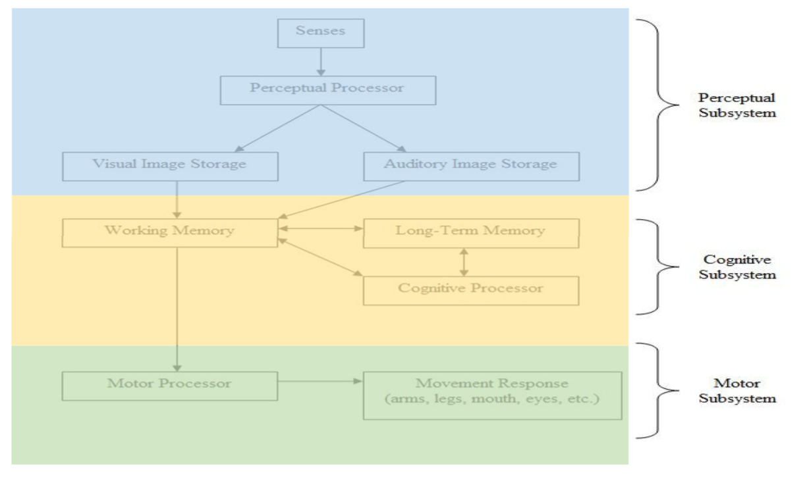

Perceptual Subsystem: Information is received, and responses are given via a number of channels
- Input Channels
  - Visual
  - Auditory
  - Haptic
- Output Channels
  - Movement
- Also, information is stored in memory
  - Sensory
  - Working (short-term) memory
  - Long-term memory
Cognitive Subsystem: Information is processed and meaning applied
Movement Subsystem: Motor processor leads to movement response

Processor Cycle Time:
- Each processor has a cycle time
  - Tp = 100ms
  - Tc = 70ms
  - Tm = 70ms
- This allows a system designer to predict the time taken by a person to complete a task – determining the time of each operation

Memory
The Core Cognitive Aspects are:
- Perception and Recognition
- Memory
- Reading, speaking and listening
- Problem-solving, planning, reasoning and decision-making, learning
Three types of memory: 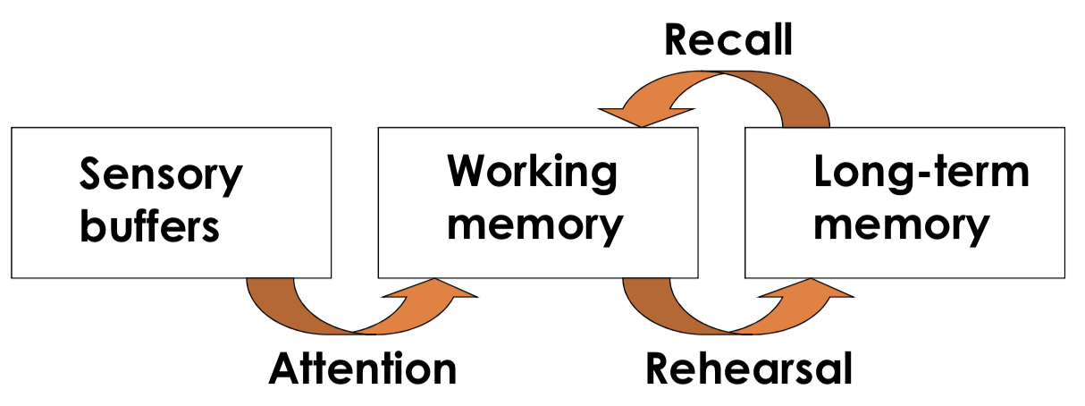
- Sensory buffers
  - Buffers from stimuli received through the senses – constantly overwritten by new information
  - Information is quickly passed into more permanent memory store (working memory)
    - By attention – concentration of the mind on one out of a number of competing stimuli or thoughts
  - Design Implications:
    - Cannot assume that because someone has seen or heard a particular message 5 seconds earlier, the person will remember it.
    - Keep message displayed until no longer needed
    - Then moves into working memory – where it will persist as long as 10 seconds
- Short-term memory
  - Working memory can be accessed rapidly – 70ms
  - Transient
  - Limited capacity – 7 ± 2 chunks of information
    - STM constrained by number of chunks, not basic elements – therefore patterns can be useful as aids to memory
  - Items lost from memory if not rehearsed
- Long-term memory
  - People store meaning or knowledge in long-term memory
  - When people are recalling units of meaningful information they are placing items from LTM in an active state (working memory)
  - Implications for Design
    - Context plays a major role in what people see and hear
    - Mind Set: Factors that we know and bring to a situation can have profound effect on usability of an interface
    - Grouping: users will always automatically try to impose a structure on the display

Storage of Information:
- Rehearsal
  - Information moves from STM to LTM
- Total time hypothesis
  - Amount retained proportional to rehearsal time
- Distribution of practise effect
  - Optimized by spreading learning over time
- Structure, meaning and familiarity
  - Makes information easier to remember

Forgetting:
- Decay
  - Information is lost gradually but very slowly
- Interference
  - New information replaces old – they may interfere
- Memory is selective
  - Affected by emotion – can subconsciously choose to forget

Retrieval:
- Recall
  - When you remember something
- Recognition
  - When presented with the item you are trying to remember

Gestalt Psychology
Gestalt Theory: Describes how the mind organises visual data – do not see things in isolation but as parts of a whole

Gestalt Laws:
- Figure-ground relationship – group elements as either figures or ground – this affects legibility
- Proximity – group by distance or location
- Similarity – group by type
- Symmetry – group by meaning
- Continuity – group by alignment
- Closure – perceive shapes that are not there

Visual Perception
- Visual Perception is active – it blends sensation and knowledge – it is the active process of interpreting the information brought to the brain by the senses.
- We have lots of selective attention and perceptual expectancy

Reading
Several stages in the reading process:
- Visual pattern of word is perceived
- Then decoded with reference to an internal representation of language
- Final stages of language processing include syntactic and semantic analysis and operate on phrases or sentences.

Expectation: What we expect to see affects what we perceive reality to be.

Colour: Perception of colour is determined by the physical context of the object

Colour Schemes:
- Different colour schemes are different combinations of colours based on relationship to each other
  - Monochromatic
    - Different tones of the same colour
  - Analogous
    - Based on colours that are adjacent to each other on colour wheel.
  - Complementary
    - Based on colours that complementary to each other on the colour wheel
  - Triadic
    - Based on three colours equally spaced around the colour wheel
- Any design should have a colour scheme

Rule Based Evaluation

GOMS and KLM
GOMS is the idea of describing the users behaviour in terms of:
- Goals
- Operators – perceptual, motor and cognitive acts
- Methods – procedure for using operators to accomplish goals
- Selection rules – if several methods available for single goal

GOMS Analysis checks that frequent goals can be achieved quickly (help us to compare different UI designs) – by making operator hierarchy. We also need to consider operator sequence – what order are operations done?

How?
- Pick high level user goal
- Write methods for reaching goals - subgoals
- Write methods for subgoals, etc
  - Until we reach operators

Operators have specific execution time, therefore summing the execution times mean we get time to perform serial operators. There are a specific set of operators for keystroke level model (KLM):
- Keying – K
  - 0.2s
- Pointing – P
  - 1.1s
- Homing – H – time taken for a user to move hand from keyboard to mouse, or vice versa
  - 0.4s
- Mentally Preparing – M
  - 1.35s
  - Should be placed in front of all Ks and in front of all Ps that selects commands
  - If operator following an M is fully anticipated in the operator just previous to that M, then delete the M.
  - If a string of MKs belong to a cognitive unit then delete all Ms but the first
  - No M between chars of a delimiter and character
  - No M before ‘enter’ at the end
  - Don’t count any portion of an M that overlaps an R.
- Responding – R – time user must wait for a computer to respond to input
  - Any changes > 0.25s should have a response

+:
- Gives qualitative and quantitative measures
- Model explains the results
- Less work than user study
- Easy to modify when UI revised

-:
- Not as easy as other evaluation methods
- Takes lots of time and effort
- Only works for goal-directed tasks
- Assumes tasks expert performance without error
- Does not address several UI issues

Fitts’ Law
Estimate movement time to select a target on a computer display – robust model of human psychomotor behaviour developed in 1954. It enables the prediction of human movement and human motion based on rapid, aimed movement. Movement time is affected by the distance moved and the precision demanded by the size of the target – precision measured by the index of difficulty.

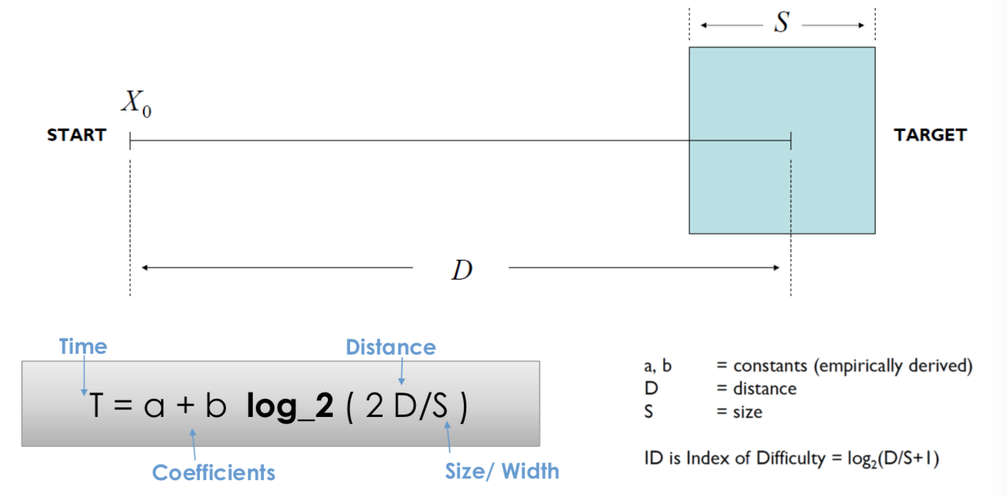

The model considers a well-rehearsed selection task – T increases as the target increases and T decreases as the size of the target increases. A and b are determined experimentally and are mostly dependent on the pointing device.

Index of Difficulty
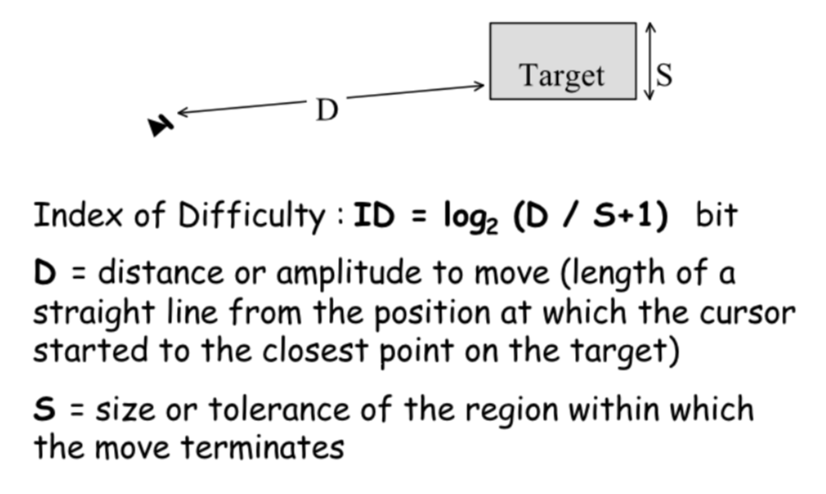
Applicability: Only applies to motions that are small relative to human body size and uninterrupted – one continuous motion.

Hicks Law
Method to estimate time taken to make a selection decision – more choices -> longer time taken to come to a decision:
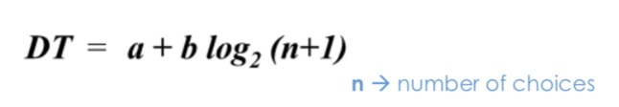
A and b are dependent on many conditions, including how the choices are presented and how used to the system the user is:
- If choices are presented in a confusing manner, both a and b increase.
- Habituation decreases b

Heuristic Evaluation
Helps us to find usability problems in a UI – sketches or a real thing. We utilise a small set of evaluators (they do not need to be real people), each of whom checks for compliance with usability principles – heuristics. At the end, the problems are compiled and used to inform the re-design.

- Visibility of System Status
  - Keep users informed as to what is going on within a reasonable time
- Match between system and real world
  - Speak the users’ language
  - Ensure the terminology of your model meets their model
- User control and freedom
  - Idea that the user model is not necessarily shared by the system model
  - No modal dialogs – system-imposed view – the user should not be forced down fixed paths
  - Therefore, clearly marked exits - undo
- Consistency and standards
  - Consistency within (and between) applications
- Error prevention
- Recognition rather than recall
  - Minimise the user’s memory load – things should be easily visible and retrievable
- Flexibility and efficiency of use
  - Support frequent tasks with high cognitive load
  - Allow people to do the same job in multiple different ways depending on how people think
  - Macros, keyboard shortcuts
- Aesthetic and minimalist design
  - Draw users focus to the main subject – keep information displayed on the application simple
  - Categorizing
- Help users recognise and recover from errors
  - Error messages in plain text
  - Precise solutions
- Help and documentation
  - Modal, contextual help section (list of concrete steps)

Severity Ratings: Rating of how bad a problem something is in terms of: (1) frequency, (2) persistence, (3) impact:
- 0 – do not agree that it is a usability problem
- 1 – cosmetic problem
- 2 – minor usability problem
- 3 – major usability problem
- 4 – usability catastrophe

Performing Heuristic Evaluation
- Pre-evaluation training – get evaluators up to speed on domain and scenarios used
- Evaluate – evaluators individually use UI according to scenarios (twice: once for overview, once for detail)
- Collate results
- Rate severity
- Feedback into design

+:
- Cheap and quick
- Easy to learn
- Finds lots of problems

-:
- Not task focused
- Not using actual people
- Not rigorous

Cognitive Walkthrough
CW is a task-centred evaluation, focussing on real, complete and representative tasks. The focus is on issues that users will have when they first use an interface, without training, therefore assesses learnability.

Why?
- Question assumptions about what user thinking
- Identify missing / hard to find controls
- Finding places with inadequate feedback
- Finding issues with labels or prompts
- Comparison to other techniques
  - Severe Problems
    - Similar
  - Content-related problems
    - Comparable for consistency
    - Worse for recurrence
  - Scope
    - Finds more specific problems

Dependencies:
- Description / prototype of the interface
- Task description for a representative task
- Complete list of actions needed to complete the task
- Idea of who the users will be and their experience

Methodology
- Define inputs
  - Who are users
  - What are tasks
  - What are action sequences
- Get analysts – do not need to be actual users
  - Can also emulate a class of users
  - Can be generally done by a developer
- Step through action sequences for each task
  - Will users know what to do?
  - Will users see how?
  - Will users understand whether their actions are correct or not (is feedback good?)
- Record important information
  - User knowledge before and after
  - Side issues and design changes
  - Credible Success or Failure Story
    - Did they / would they have managed it?
- Revise UI

-:
- Cannot evaluate every task the user will perform
- Each task is evaluated separately – no cross-talk interactions are identified
- Therefore, task-free, user-centred method is required to be brought in to catch problems that CW may have missed.
  - For example, heuristic evaluation

