Foundations of Data Science
Cambridge Computer Science Tripos Part IB, Paper 6
Ashwin Ahuja
2019
Table of Contents
Probabilistic Modelling 2
Likelihood 2
Random Variables 2
Independence and joint distributions 3
Rules for Conditional Probability 3
Rules for Joint Distributions of Random Variables 3
Fitting Distributions 4
Custom Distributions 4
Inversion Method 4
Fitting a model 5
Random Variables 6
Mean and Variance 6
Confidence Intervals 6
Convergence Theorems 7
Monte Carlo integration 8
Empirical Distribution 9
Standard Random Variables 9
Geometric 9
Exponential 9
Binomial 10
Multinomial 10
Poisson 10
Normal / Gaussian 10
Pareto and Lognormal 11
Zipf 11
Beta 11
Dirichlet 11
Gamma 11
Inference 12
Bayesianism 12
Nuisance Parameters 14
Frequentism 14
Resampling 15
Model Selection 15
Hypothesis Testing and P-Values 15
Alternative Hypothesis 16
Creating a Model 16
Logistic Regression 16
Feature Spaces 16
Fitting a linear model 16
Features 17
Linear Mathematics 18
Orthogonal Projection 18
Linear Regression and Least Squares 19
Random Processes 19
Markov Chains 19
Limit theorems and equilibrium 20
Detailed Balance 20
Limiting Behaviour and Aperiodicity 21

Probabilistic Modelling

Likelihood
Likelihood is the probability of the observed outcome, viewed as a function of the unknown parameter. Important to note that likelihood is not a probability density – does not integrate to 1. The likelihood function measures how much evidence there is for a particular parameter value. The maximum likelihood estimator is the parameter value with the maximum likelihood.

Example: take a biased coin. Likelihood function is how much evidence there is for a particular value of p. The higher lik(p) is, the more likely that value of p is.
$$lik\left(p | x\right)= \left({n \atop x}\right)p^{x}{\left(1-p\right)}^{n-x}$$
In order to get the value which maximise the likelihood, we solve:
$$\frac{d}{dp}lik\left(p\right)= \left({n \atop x}\right)\left(xp^{x-1}{\left(1-p\right)}^{n-x}-\left(n-x\right)p^{x}{\left(1-p\right)}^{n-x-1}\right)= 0$$
Often, easier to maximise log(lik(.)) rather than lik(.) and it necessarily has the same solution:
$$\log{lik\left(p\right)}=k+xlog p+\left(n-x\right)\log\left(1-p\right) where k is a constant$$
$$\frac{d}{dp}\log{lik\left(p\right)=\frac{x}{p}-\frac{n-x}{1-p}}=0=>p=\frac{x}{n}$$

Random Variables
Random Variable is a function that can give different answers. It takes values in Ω means that the return value of the function is an element of the set Ω. Every random variable X has a probability distribution:
$$P\left(x∈A\right)$$
which specifies the probability that the return value lies in a subset A ⊆Ω – if Ω is countable, the random variable is said to be discrete and then:
$$P\left(x∈A\right)= \sum_{x ∈A}{P\left(X=x\right)}$$
For many applications, work with real-valued random variables, and define the cumulative distribution function, to be:
$$F\left(x\right)=P\left(X≤x\right)$$
If the function is differentiable, then X is said to be a continuous random variable with density function f(x) = F’(x) and:
$$P\left(X≤x\right)= \int_{-∞}^{x}{f\left(x\right) dx}$$
For a continuous random variable, ℙ(X = x) = 0 for every x, and so:
$$P\left(a≤X≤b\right)=P\left(a<X≤b\right)=P\left(a≤X<b\right)=P(a<X<b)$$

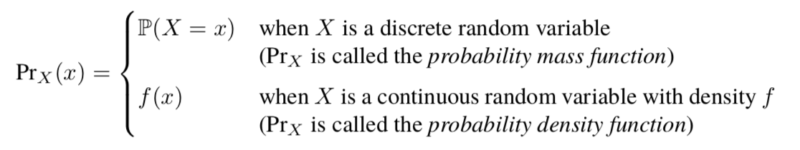
A conditional random variable (X | C) is just a random variable whose distribution is conditional: if Y = (X | C) then ℙ(Y ∈ A) = ℙ(X ∈ A | C)
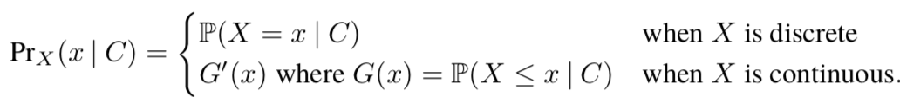

Independence and joint distributions
Any pair of random variables (X, Y) has a joint distribution which specifies the probability of any joint event C. For a pair of continuous random variables, the joint distribution can be specified by a joint probability density Pr_{X, Y} (x, y)
$$P(\left(x, y\right)∈C)=\int_{\left(x, y\right) ∈ C}^{ }{Pr_{X, Y}\left(x, y\right)}{dx dy}$$
The marginal density of X is:
$$Pr_{X}\left(x\right)=\int_{y}^{ }{Pr_{X, Y}\left(x, y\right) dy}$$
When random variables are discrete, you can just replace integrals by sums.

Independence: Random variables are independent iff:
$$P\left(X∈A, Y∈B\right)=P\left(X∈A\right) P\left(Y∈B\right) for all A, B$$
$$OR Pr_{X, Y}\left(x, y\right)= Pr_{X}\left(x\right) Pr_{Y}\left(y\right) for all x, y$$
$$OR P\left(X∈A \right| Y∈B)=P(X∈A) for all A and B with P(Y∈B)>0$$

Rules for Conditional Probability
A and B are events:
- P(Ω) = 1 where Ω is the entire sample space
- Conditional probability: ℙ(A | B) = ℙ(A ⋂ B) / ℙ(B), when ℙ(B) > 0
- Sum Rule: If {B1, B2, …} partition Ω then ℙ(A) = ∑_{i} ℙ(A ⋂ B_{i})
  - Law of total probability: ℙ(A) = ∑_{i}ℙ(Bi)ℙ(A | B_{i})
- A and B are independent iff$P\left(A, B\right)=P\left(A\right) P\left(B\right)$
- Bayes Rule
  - 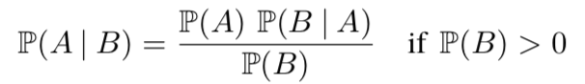

Rules for Joint Distributions of Random Variables
For continuous random variables, replace sums by integrals:
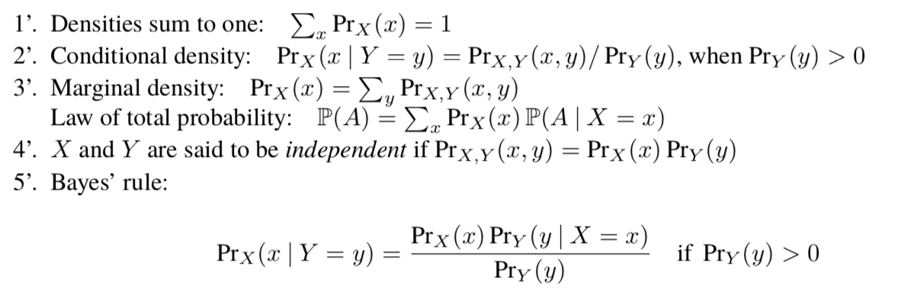

Fitting Distributions
Random sample is a collection of random variables all drawn from the same distribution, and all independent of each other. If Y = (X₁, …, X_{n}) is the random sample and y = (x₁, …, x_{n}) is a collection of values (dataset) then:
$${Pr}_{Y}\left(y\right)=Pr_{X}\left(x_{1}\right)×… × Pr_{X}(x_{n})$$
Where X is the common distribution. We also say X1, …, Xn are independent and identically distributed. If distribution of X depends on some parameter Θ which we’d like to estimate given a dataset. The likelihood given a single observation is:
$$lik\left(θ \right| x)=Pr_{X}\left(x \right| θ)$$
And the likelihood given a dataset is:
$$lik\left(θ \right| x_{1},…, x_{n})={Pr}_{X}(x_{1} \left| θ\right)×… × {Pr}_{X}\left(x_{n} \right| θ)$$
Fitting the distribution means finding the maximum likelihood estimator for Θ, solving:
$$\hat{θ}={argmax}_{θ}\log{lik\left(θ \right| x_{1},…, x_{n})}$$

Using Python:
# Numerical solution (using a scaled loglik, for numerical stability)
def loglik(p, x):
return numpy.log(p) + (numpy.mean(x) − 1) * numpy.log(1−p)
initial_guess = numpy. array ([0.5])
mle = scipy.optimize.fmin(lambda p: −loglik(p,x), initial_guess)
(p,) = mle #unpack mle, which is a list of length 1

Multiple parameters: Differentiate with respect to each in turn and then find where derivative is zero and then solve the simultaneous equations

Custom Distributions
In order to design a distribution function is to plot the empirical cumulative distribution function:
$$\hat{F}\left(x\right)=\frac{1}{n}(how many items there are≤x)$$
From there, if the data moves too fast, take logs, then alter it – and split it into a thing where you can find straight lines from the distribution and then doing a MLE for all the parameters.

Inversion Method
- Generate a simple random variable U ∼ Uniform[0, 1]
- Solve F(X) = U for X
- Now X has cumulative distribution function F

Why it works: ensures for ever x the event {X ≤ x} is precisely the event {U ≤ F(x)} which has the probability F(x). In regions where density of Pr_{X} is high then F will be steep, and so U is more likely to hit those regions.

This requires us to solve F(X) = U, which is easy to do algebraically for continuous functions like the straight lines fit. Method also correct for discrete random variables.

Fitting a model
Multivariate dataset: contains records each consisting of a tuple of values. We want to understand how one item in the tuple depends on the others. The item we want to understand is called the response variable and the others are called covariates or predictors

Invent a probabilistic model in which we treat the response as a random variable, whose distribution depends on both the covariates and on unknown parameters. Use the maximum likelihood estimation to estimate the unknown parameters – this is fitting the model.

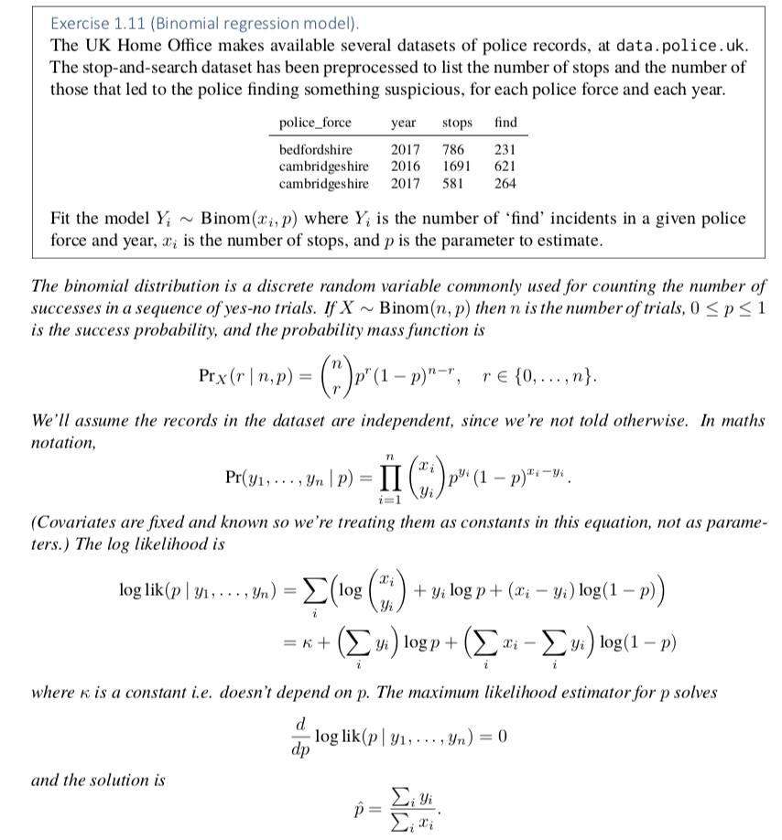

Random Variables

Mean and Variance
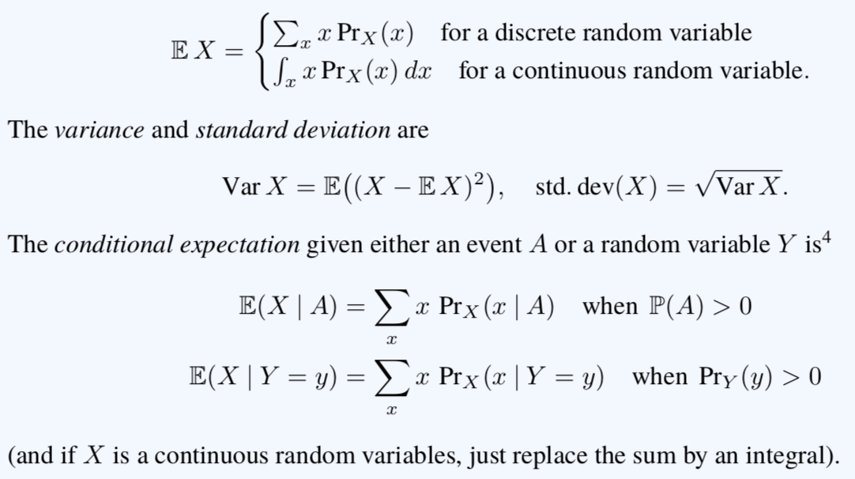
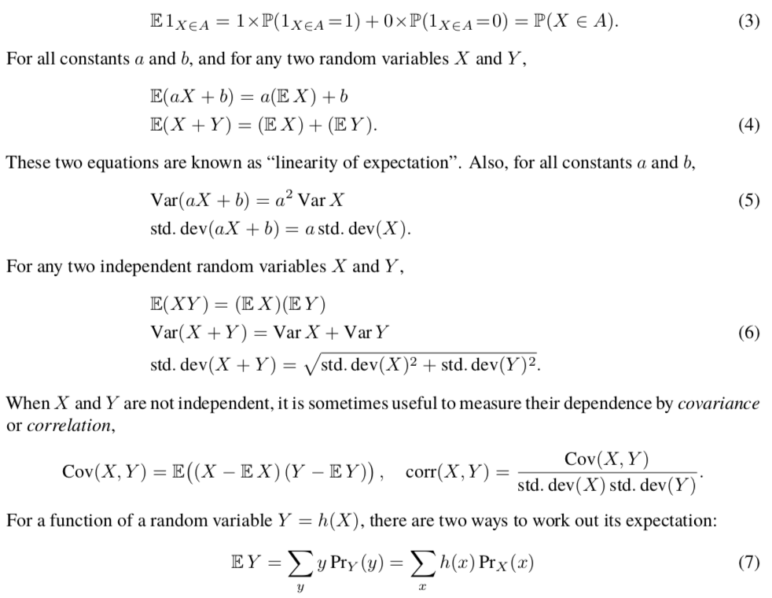

Confidence Intervals
A random variable can be approximated by:
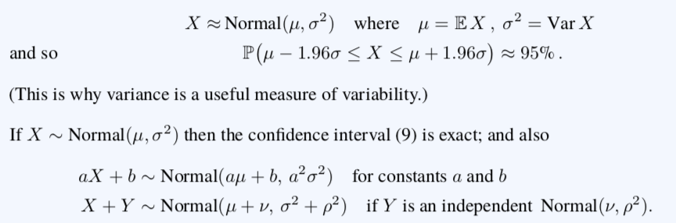

Convergence Theorems
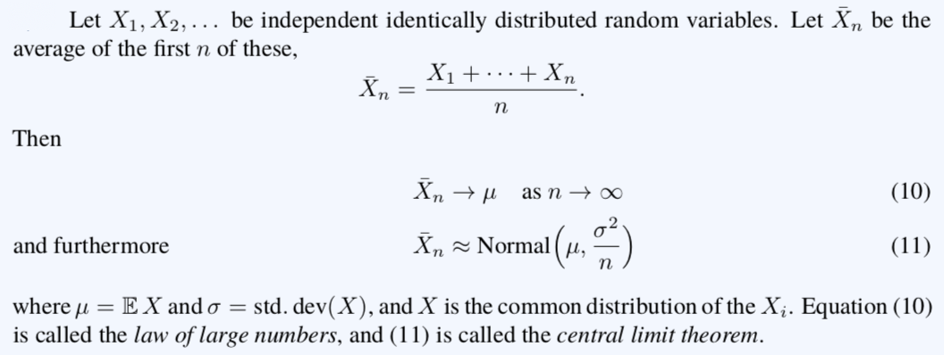

Law of Large Numbers 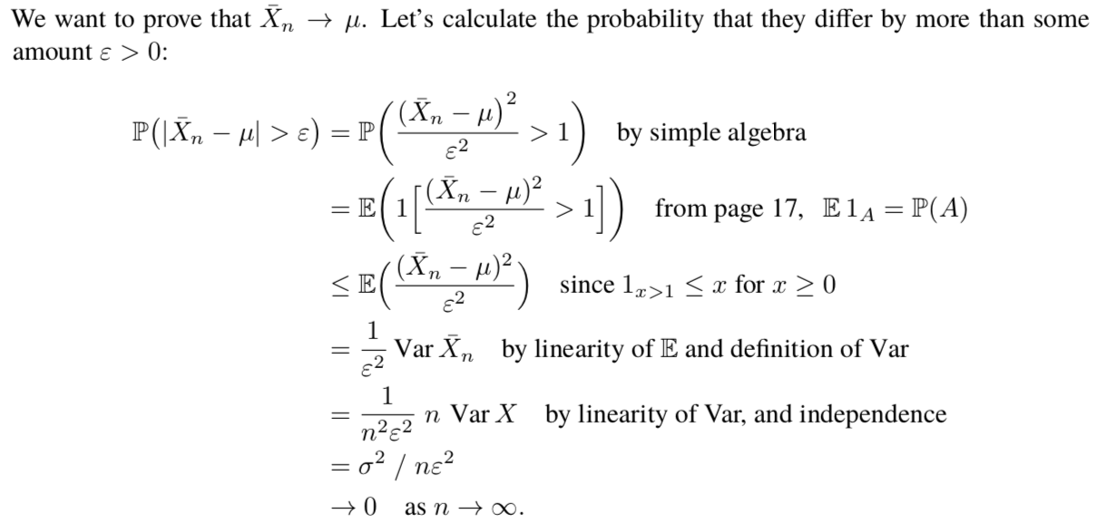
Weak law of large numbers: ℙ(|$\overline{X_{n}}$ – μ| > ε) -> 0
Strong law of large numbers: ℙ($\overline{X_{n}}$ -> μ) = 1 (this implies the weak law)

Therefore $\overline{X_{n}}$ approaches μ as n -> ∞ and the smaller σ is, the smaller the error is likely to be. The central limit theorem additionally lets us find a confidence interval for the error.

Central Limit Theorem

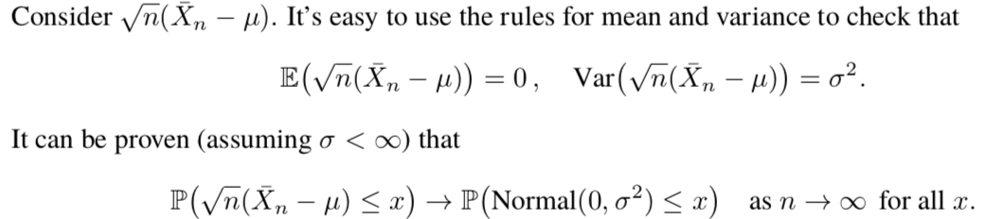

Monte Carlo integration
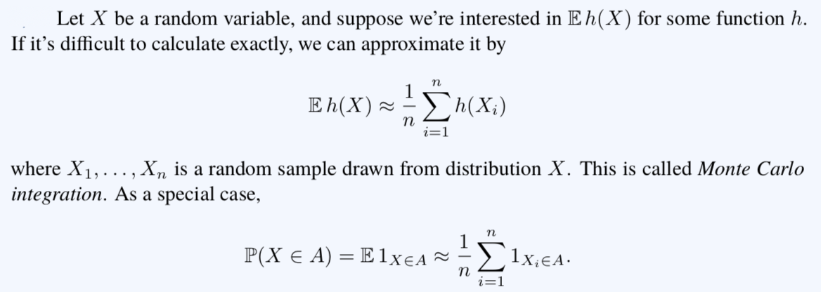

Why it works: where trapezium method, etc, split the integral into equally sized pieces, there is no real reason to do this, can just pick independent random variables and approximate:
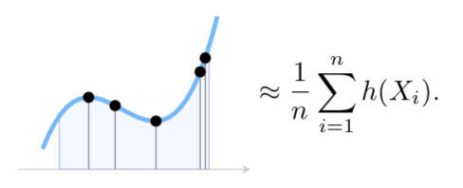
Error of the Monte Carlo estimator: O(σ/$\sqrt{n}$) – however, need to be able to calculate σ, which is easier to estimate using the Monte Carlo method rather than calculating
$$σ^{2}= E{\left(X-μ\right)}^{2}≈\frac{1}{n}\sum_{i=1}^{n}{{\left(X_{i}-μ\right)}^{2}}$$
can plug in estimate for μ using Monte Carlo method – can keep a running estimate of σ and can stop when the error gets small enough.

Empirical Distribution
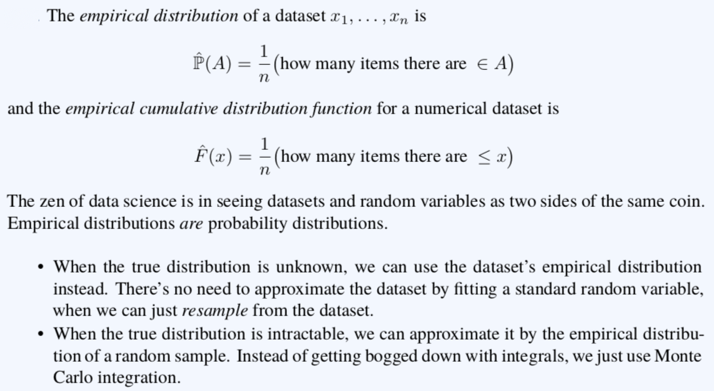

Resampling: Sample from the empirical distribution function using the inversion method – the same as picking a value at random from the dataset, with each item being equally likely. For a parametric distribution, we only need to store a handful of parameters, rather than the full dataset. Can also have high-dimensional modelling (active research topic) – modelling with more parameters than there are samples in the dataset.

Standard Random Variables

Geometric
X ∼ Geom(p)
Takes values in {1, 2, …, n}
Mean: 1/p
Variance: (1-p)/p²
Python: numpy.random.geometric(p)

Exponential
Used to model the time until an event – such as the time until a lump of radioactive matter emits its next particle.

X ∼ Exp(λ) – λ is called the rate
Takes values in [0, ∞]
Chance of an event in a short interval of time [t, t + δ] is:
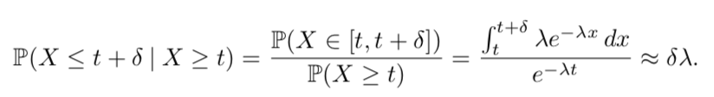
Mean: 1/λ
Variance: 1/ λ²
Python: numpy.random.exponential(scale = 1/λ)

Binomial
Toss a biased coin n times, and each coin has chance p of heads, total number of heads. When n is 1, it’s called a Bernoulli random variable.

X ∼ Binom(n, p)
Takes values in {0, 1, …, n}
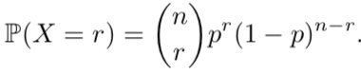
Mean: np
Variance: np(1-p)
Python: numpy.random.binomial(n, p)

Multinomial
N individuals each of whom falls into one of K categories and probability of falling into category k is p_{k}

X ∼ Multinom(n, p)
Takes values in {0, 1, …, n}^{K}
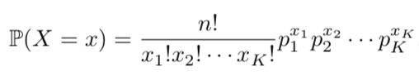
Python: numpy.random.multinomial(n, p)

Poisson
If time between events is exp(λ) then total number of events in time t.

X ∼ Poisson(λt)
Takes value in {0, 1, …}
Mean and Variance: λ
Python: numpy.random.poisson(lam = λ)

Normal / Gaussian
Good aggregate of lots of small pieces:

X ∼ Normal(μ, σ²)
Takes value in reals
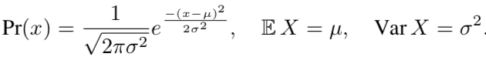
If you have two independent distributions X ∼ Normal(μ, σ²) and Y ∼ Normal(ν, ⍴²) and a and b are real numbers
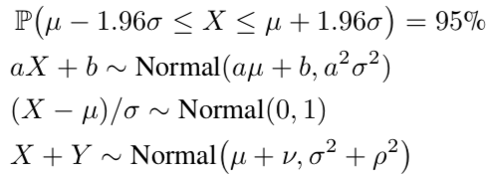
Python: numpy.random.normal(loc=μ, scale=σ)

Pareto and Lognormal
Avoid reliance on a single black swan event.

X ∼ Pareto(α)
Takes values in [0, ∞]
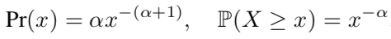
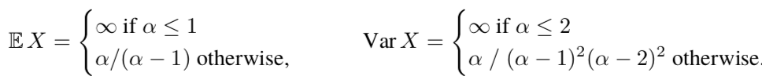
For α < 2, it tends to produce many small values and very occasional huge values

Zipf
Describes frequencies of words in texts – comparing rank and frequency.

X ∼ Zipf(n, s)
Takes values in {0, 1, …, n}
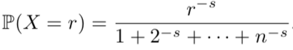

Beta
If we toss a biased coin n times, and each coin has chance p of heads, then number of heads takes Bin(n, p). A common prior distribution for p is Beta(α, β).

Takes values in (0, 1) and has parameters α > 0 and β > 0
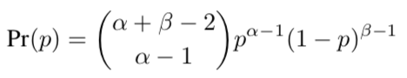
Mean: α/(α + β)
Python: numpy.random.beta(a=α, b=β)

Dirichlet
Generalisation of Beta – has k categories and α is a vector in ℝ^{K}
Takes value in
Generates probability distributions over the k categories – used in Bayesian inference to describe belief about a multinomial distribution – interpretation is “seen α_{k} items in category k”
Python: numpy.random.dirichlet(alpha=α)

Gamma
Sum of k independent exponential random variables – common choice of prior distribution for 1/σ² in Bayesian calculations with Normal(μ, σ²)

X ∼ Γ(k, λ)
Takes values in [0, ∞]
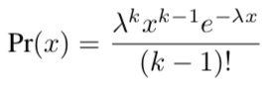
(k-1)! Is replaced by gamma function Γ(k) for non-integer k
Mean: kλ
Variance: k/λ²
Python: numpy.random.gamma(shape=k, scale=1/λ)

Inference
Reaching conclusions on the basis of data and reasoning.

Bayesianism
Doctrine that one should represent uncertainty about unknown parameters by describing them as random variables. It insists that we set down a prior belief for all unknown parameters before we even think about incorporating data – doesn’t really matter what the prior is as long as the dataset is large enough

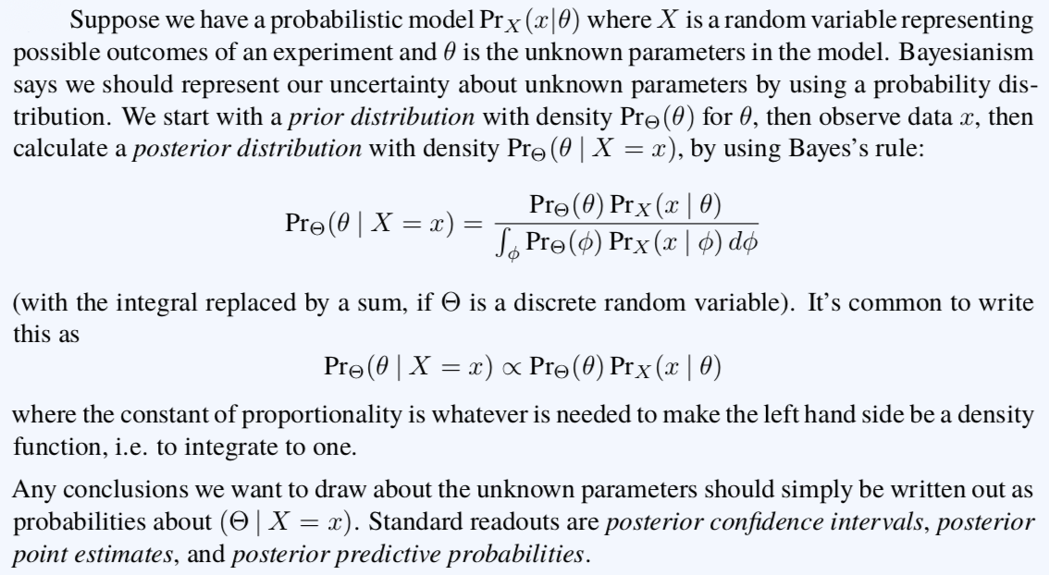

Conjugate Priors: When posterior distribution ends up belonging to the same family as the prior distribution, just with different parameters

Sampling from posterior distribution: Can use the Gibbs sampler (based on Markov chains) to simple from a posterior distribution

Readouts from posterior distribution: For example, to see if a coin is biased, see if ℙ(Θ > ½ | X = 9) – can get this through integrating the probability from ½ to 1, or by resampling using the posterior distribution then using Monte Carlo integration

Confidence Interval: Can report confidence interval, therefore for Θ is a Uniform[0, 1]
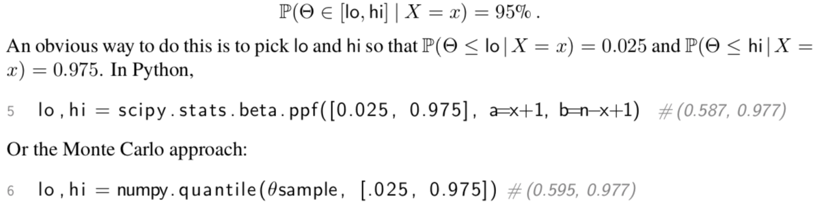

Posterior Point Estimates: When asked given the observed data what is the value of the parameter:
- Report value of parameter that maximises the mode of the posterior distribution. This is the maximum a posteriori (MAP) estimate
- Return mean or median of the posterior distribution
- Report a loss function, which measures the price you pay if you report the estimate and the true value. Report Θ’ which minimises the expected posterior loss.

Posterior Predictive Probability: Probability that the next event will be something. Can use the law of total probability. For example, for the example of a coin flip – looking for probability next flip X’ will be a head
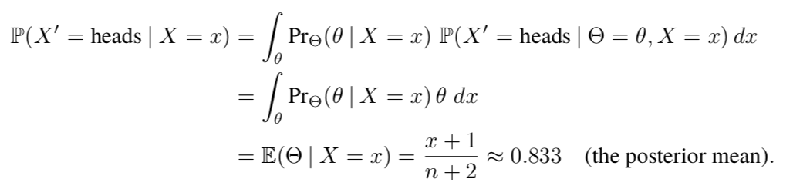
The Python for this is: numpy.mean(Θsample)

Nuisance Parameters
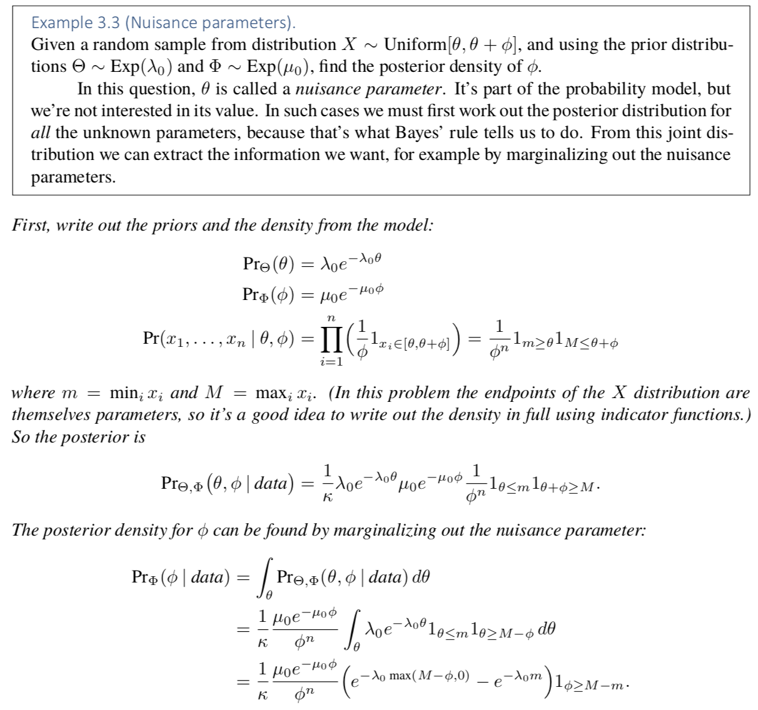

Frequentism
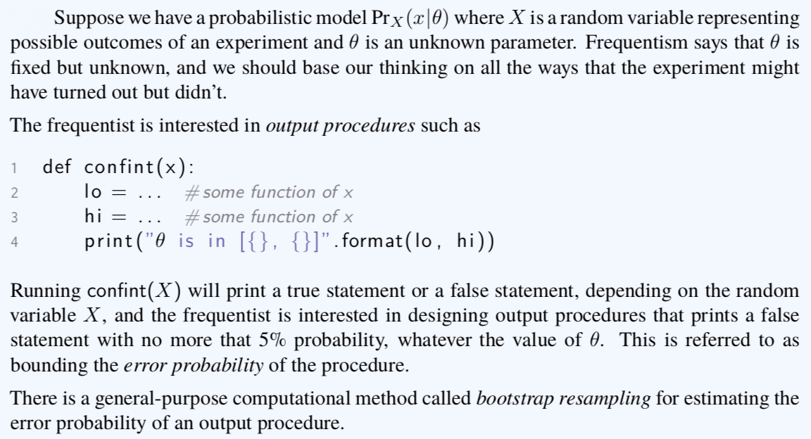

Resampling
If the trial were run again, what is a good way to use the data at hand to synthesize a result I could plausibly see

Parametric: (1) specify a probability model with unknown parameters, (2) fit the parameters using maximum likelihood (3) sample from the fitted probability

This relies on some sort of intuition – resample using intuition and parameters which have been found.

The Bootstrap: removes any need for maths or exhaustive optimization for bounding the error probability
- Write probability you’re interested in
- Replace any unknown parameters by the MLE given the data – replace any random variables by their resampled versions
- Use the Monte Carlo method to estimate the probability of the expression in step 2

Non-Parametric: Sample from the empirical distribution, which is equivalent to picking a value at random from the observed dataset. The idea is that the best-fitting distribution is the dataset itself – can then do Monte Carlo integration or draw a histogram
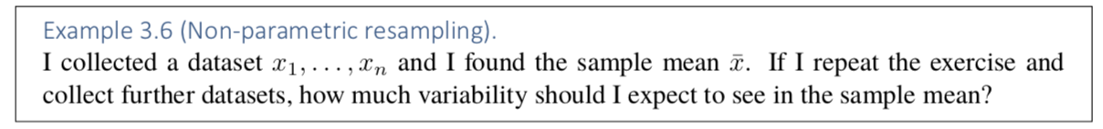
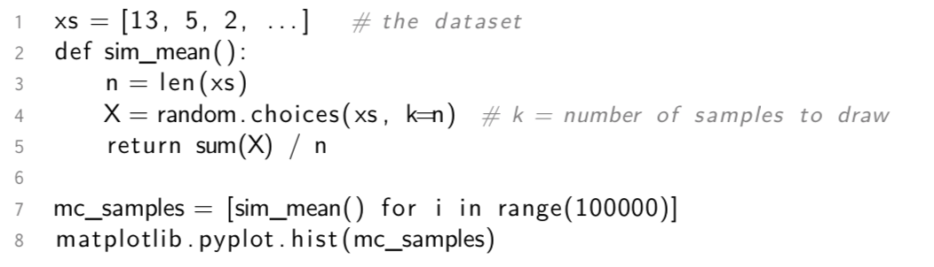

Model Selection
Model: explanation for the data – simpler models are likely to be closer to the truth and to generalise better to new scenarios. Can also be used to make predictions about new data.

Hypothesis Testing and P-Values
Come up with a null hypothesis and see if you reject it or not.
- Define a function test_statistic(y) – can be any function of the data. We aim for a function that is likely to be small if the null hypothesis is true and large if it is false.
- Assuming the null hypothesis is true, find the distribution of T = test_statistic(Y) – through resampling
- From the actual data – compute t = test_statistic(y). Mark t on histogram and measure p = ℙ(T > t)
- If p ≤ 5%, reject null hypothesis, otherwise don’t reject it

p is the p-value or significance level, and it measures the probability of seeing results as extreme as we can actually saw, assuming null hypothesis is true.

Alternative Hypothesis
test_statistic(Y) = lik(model = A | Y = y) / lik(model = B | Y = y) where the likelihood of a model is found by maximising over all parameters in the model.

This is the likelihood ratio test and allows us to decide between two different models – if model B is false, then the denominator will be small, so test statistic will be large.

Creating a Model
Purposes of unknown parameters:
- Make the model expressive
- When we fit the model and inspect the estimated parameters, we learn which patterns are actually present in the dataset.

How to choose parameters:
- Use parameters that correspond to the questions we want to ask and the quantities we want to measure – identifiability
- Run maximum likelihood estimators, using a numerical optimisation library – natural parameters
  - Should map the likelihood to between 0 and 1 through a/1+a – logit and softwmax

Logistic Regression
Logistic – uses the logic transform for parameters
Regression – has a response variable predicted by covariates

Feature Spaces
Feature: any measurable property of the objects being studied.
Linear Model: model with unknown parameters in which the parameters are weighted by features and combined linearly

Fitting a linear model
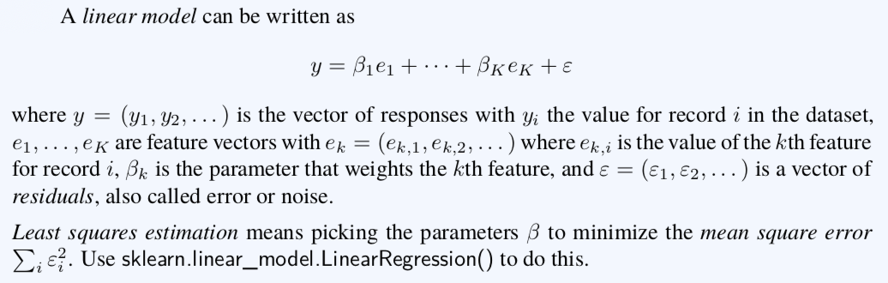
Important Note: Linear doesn’t mean straight line – simply means linear algebra (adding vectors), but can have x² as a vector

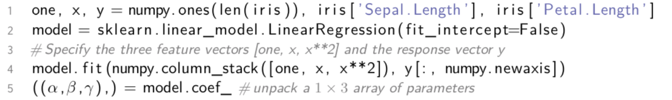

sklearn model fitting function includes a one vector unless we explicitly tell it otherwise with fit_intercept=False. Can also write this as:

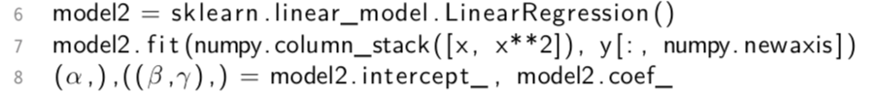

Features
One-Hot Encoding: Turn an enum feature into a collection of binary features so it could be used in a linear model.
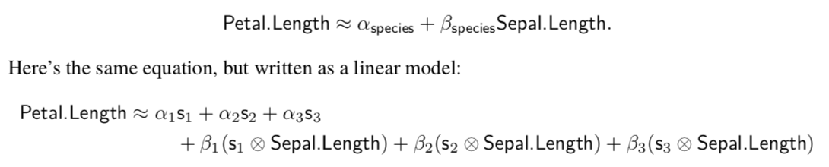
Each s_{k} is a binary vector marking out which rows belong to the kth species – one-hot coding of the vector. ⊗ means elementwise multiplication

As you add more features, the better the fit and the smaller the residual we can achieve. But a model with too many features tends to be bad at generalizing to new data. Therefore, we want to be careful about this:

Dimension Reduction: General term for finding lower-dimensional representations
- Start with long list of possible features {e1, e2, …, ek}
- Construct two new features f1 and f2 each of which a linear combination of the raw features. The goal is to construct them to minimise the errors of:
  - Y = a + B1f1 + B2f2
- Procedure gives us two features f1 and f2 that capture as much information as they can about Y – two-dimensional embedding of the dataset’s K dimensions
- Can show data on scatter plot of f1 vs f2 – likely to reveal useful clusters

Feature Selection:
- Start with long list of possible features
- Pick m, a number of features to use, and find the best fitting model subject to the constraint that it’s only allowed to use m of the possible features

Linear Mathematics
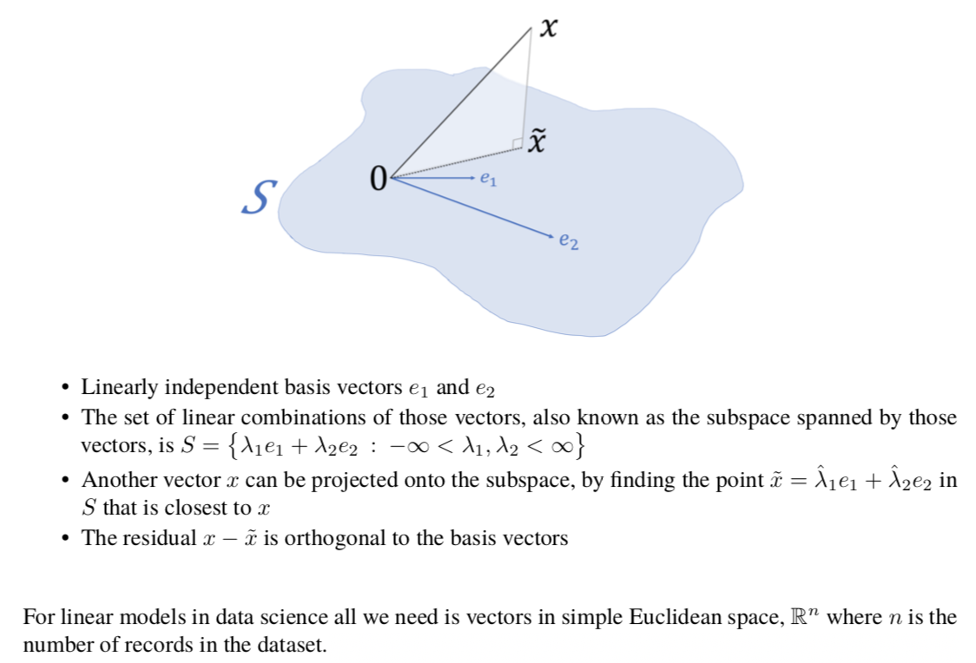

Other Definitions:
- V is the set whose elements are called vectors
- F is a field whose elements are called scalars – either reals or complex numbers
- Binary operation: V x V -> V is addition written: v + w
- Binary operation: F x V -> V is scalar multiplication, written: λv
- Binary operation: V x V -> F is inner product, written: v . w

Orthogonal Projection
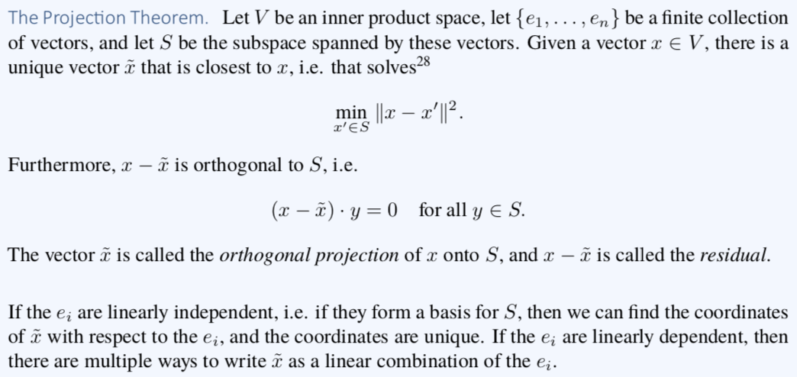

Collinearity and matrix rank: Stacked collection of vectors to form a matrix then the rank of the matrix is the dimension of the space spanned by those vectors. Use: numpy.linalg.matrix_rank(numpy.column_stack([e1, e2])))

Linear Regression and Least Squares
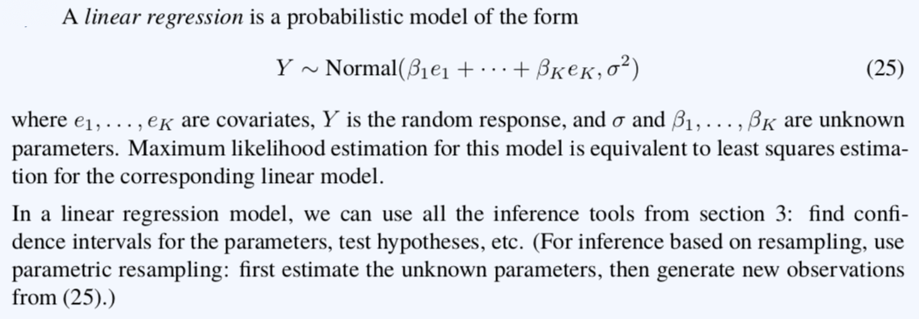

Random Processes
Random (Stochastic) Process: Using probabilistic laws to describe how the system changes

Markov Chains
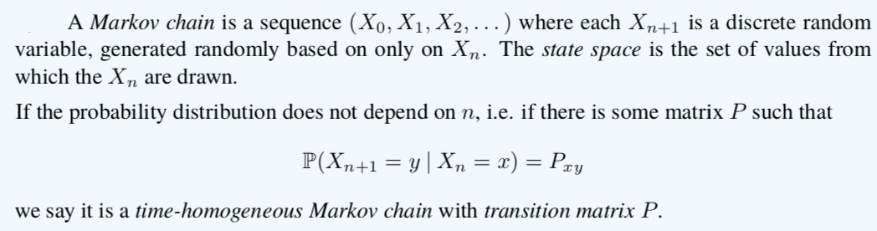

Statement of Markov Assumption:
This is a statement that whatever the history, all that matters for the purposes of deciding the next state is the current state – the is memorylessness

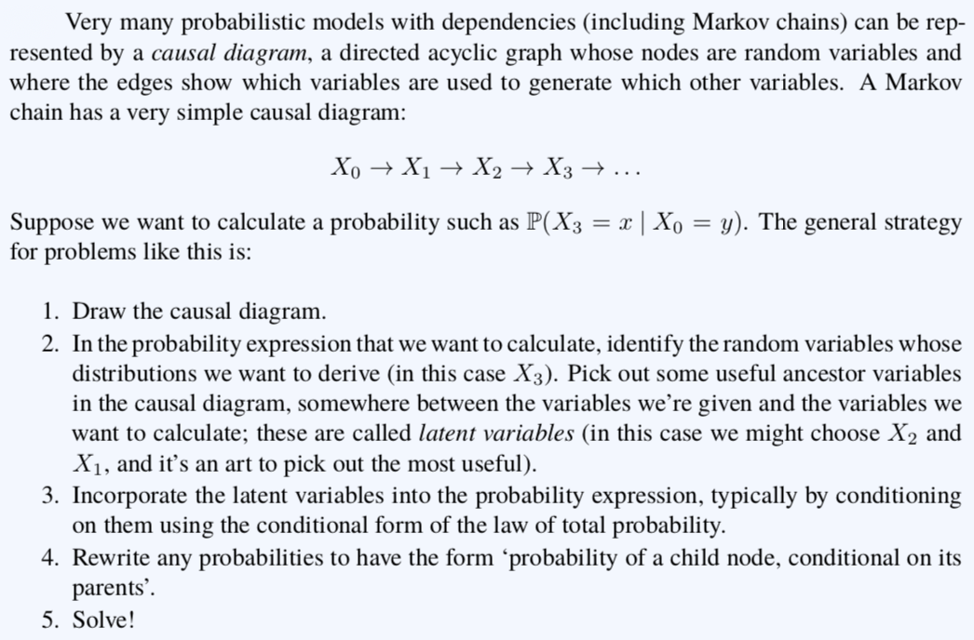
Hitting Probability Theorem: Let A be a subset of a Markov chain’s state space. The hitting probability from x is:
$$P\left(ever hit A \right| start at x)$$
These hitting probabilities solve:
$$π_{x}= \sum_{y}{P_{xy}π_{y}} for ∀x∉A, π_{x}=1 ∀x ∈A$$
If the system of equations has multiple solution, the hitting probability from $x$ is the minimum of $π_{x}$ over all solutions $π≥0$

Limit theorems and equilibrium
Aim: Look at the long-run average behaviour of a time-homogeneous Markov chain with a finite state space

Stationary: Markov chain is stationary if its distribution does not change over time, ie if there is a vector π such that ℙ(X_{n} = x) = π_{x} for all n. Conversely, if π is a probability distribution st:
then π is called a stationary or equilibrium distribution. If π is a stationary distribution, and we pick the Markov chain’s initial state X₀ randomly according to π, then X₁ will have distribution π and so on. If we pick the initial state in some other way, this is not true

Stationary distribution π must satisfy:
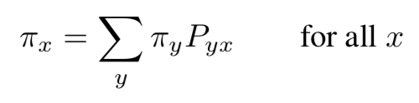
where P is the transition matrix

Theorem (Uniqueness of Stationary Distribution): Consider a Markov chain with transition matrix P and a finite state space. The Markov chain is irreducible if it is possible to get from any state to any other – this implies that the there is a unique stationary distribution and it is the unique solution to:
$$π= πP, π^{T}. 1=1$$

Detailed Balance
Can sometimes use a trick to help us find stationary distribution for a Markov chain with very little algebra – using Gibbs sampling. It also can be used to generate random variables from Bayesian posterior distribution.

Theorem (detailed balance): Let X be a Markov chain with transition matrix P. If there is a vector $π$ such that:
$$π_{x}P_{xy}= π_{y}P_{yx} for all states x and y$$
then $π$ solves $π= πP$.

Theorem (ergodicity): Let X be an irreducible Markov chain with stationary distribution $π$. Then, the long-run average time spent in each state converges to $π$. Therefore:
$$E\left(\frac{1}{n}\sum_{i=1}^{n}{1_{X_{i} =x}}\right)→ π_{x} as n→∞ for all states x$$
If Markov chain’s initial state X0 were chosen from $π$, then X_{n} would have $π$ for every n, therefore $E1_{X_{i}=x}=P\left(X_{i}=x\right)=π_{x}$, for all I, and so the equation would be true exactly.

Limiting Behaviour and Aperiodicity
Theorem: Let X be a Markov chain – a state x is said to be aperiodic if there exists an n₀ st $P\left(X_{n}=x \right|{ X}_{0}=x)>0$for all $n≥n_{0}$. If the chain is irreducible and has an aperiodic state, then all its states are aperiodic and:
$$P\left(X_{n}=x \right|{ X}_{0}=y)={\left[P^{n}\right]}_{xy}→ π_{x} as n→∞ for all states x and y$$

Can use this as a tool to generate a random variable from a distribution. Can create transition probabilities of a Markov chain to ensure it has stationary distribution as required. Then we can generate a random variable by starting the Markov chain in an arbitrary state and running it for a large number of steps and returning the state.

